Kristen Trunnelle

IST 590

Week 10 Assignment

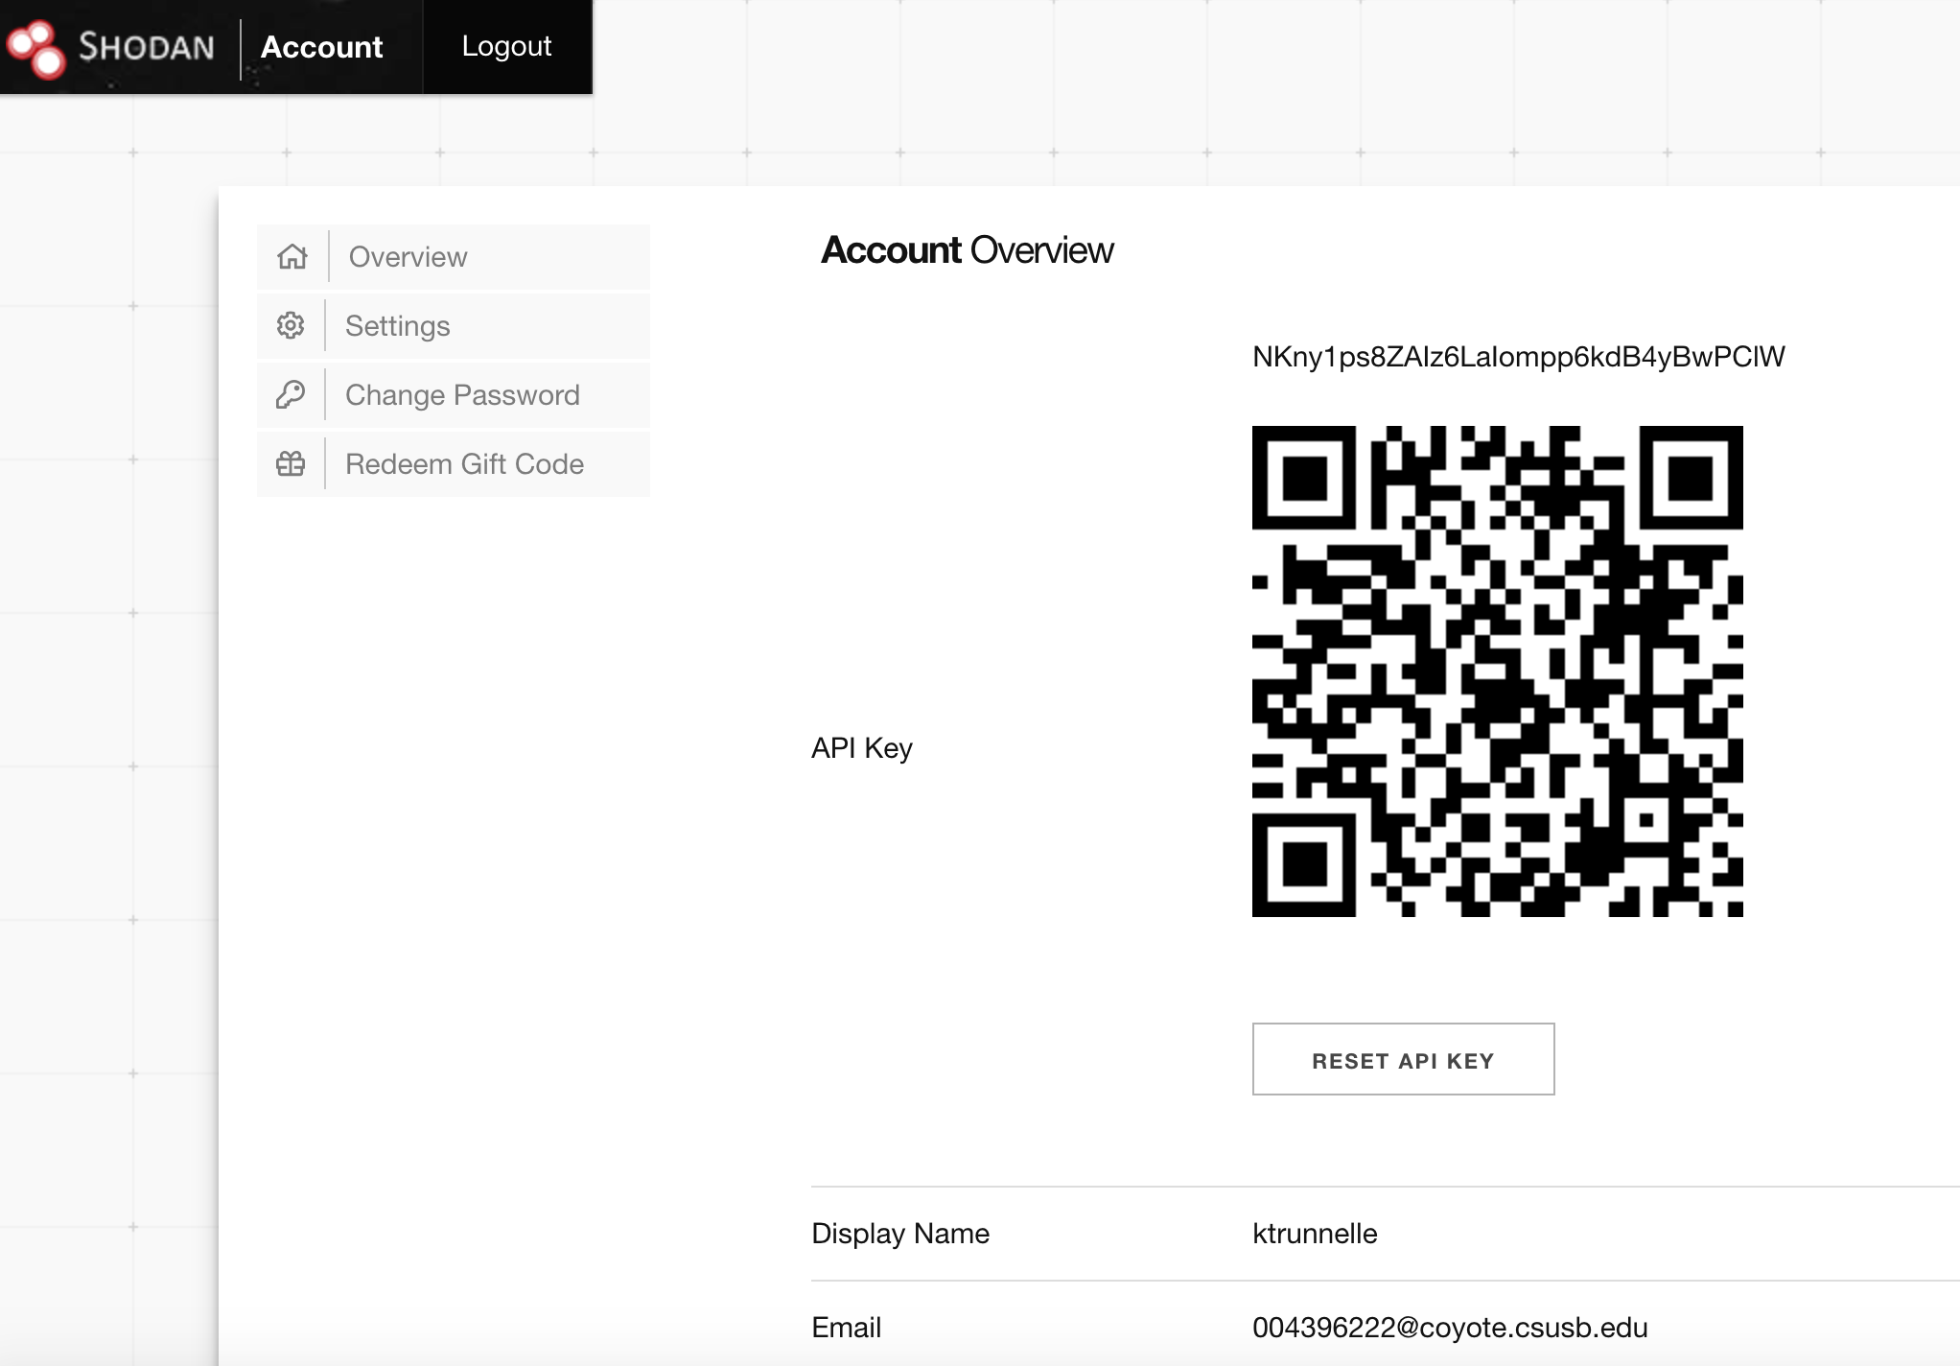

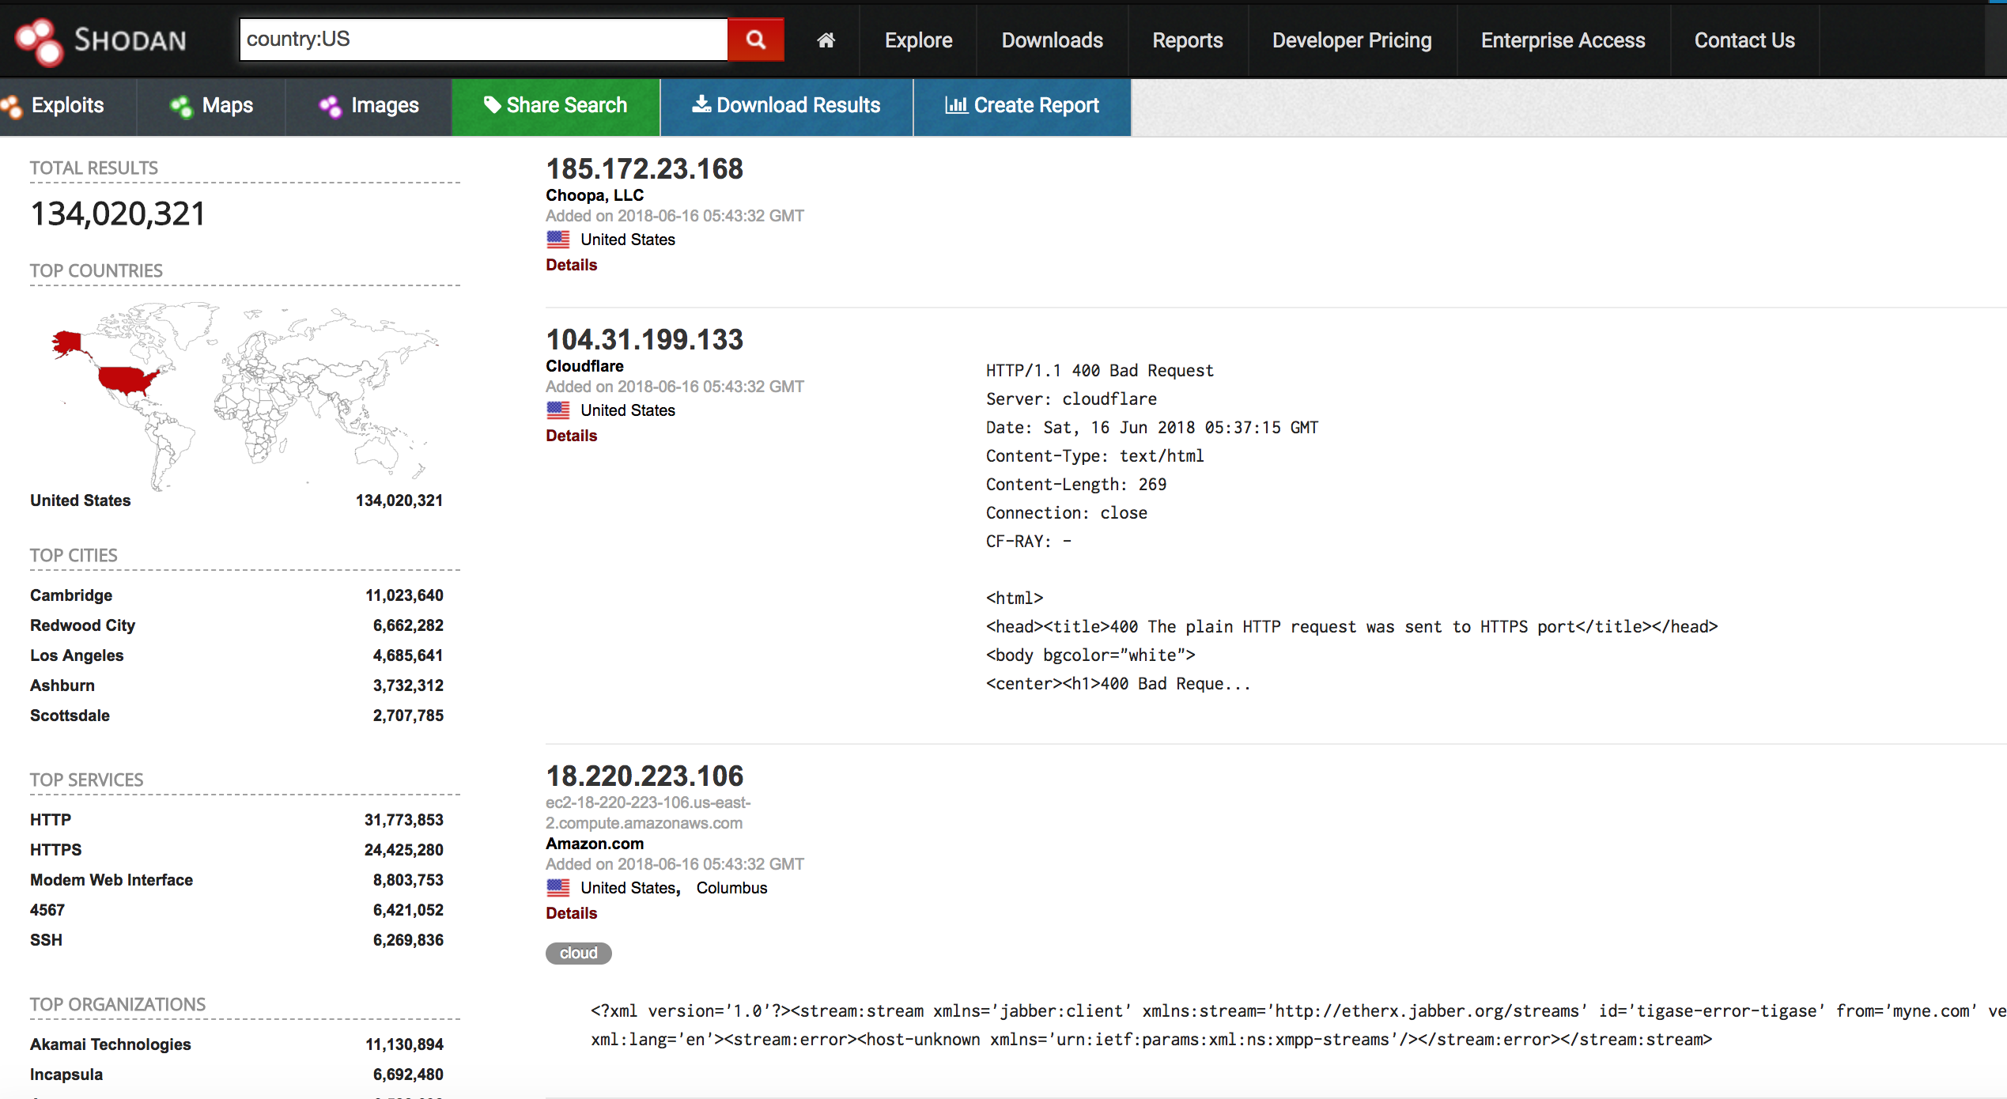

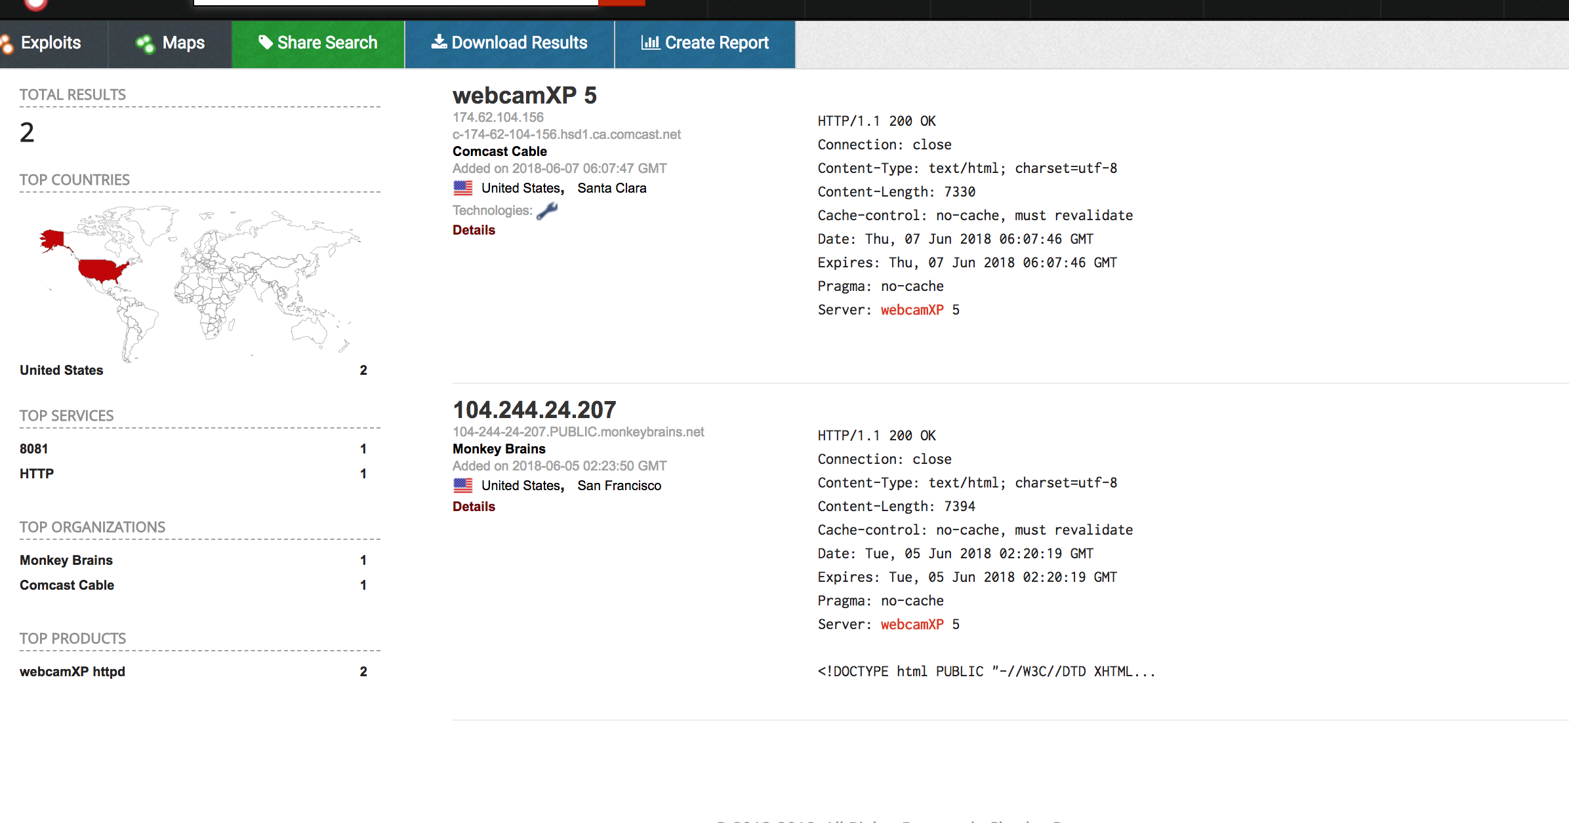

I created a Shodan account and saw some different ways to look things up.

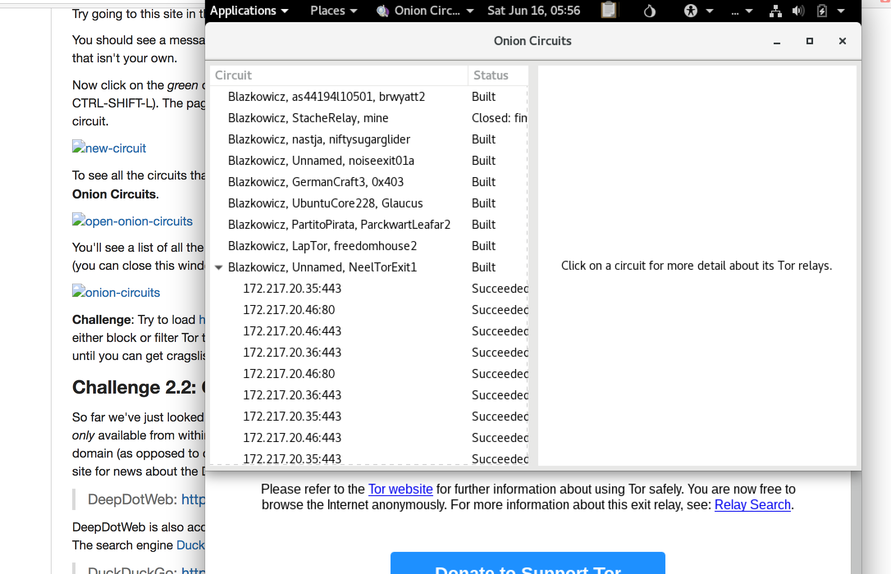

It let me go to tor site and to open a new circuit for traffic to pass through.

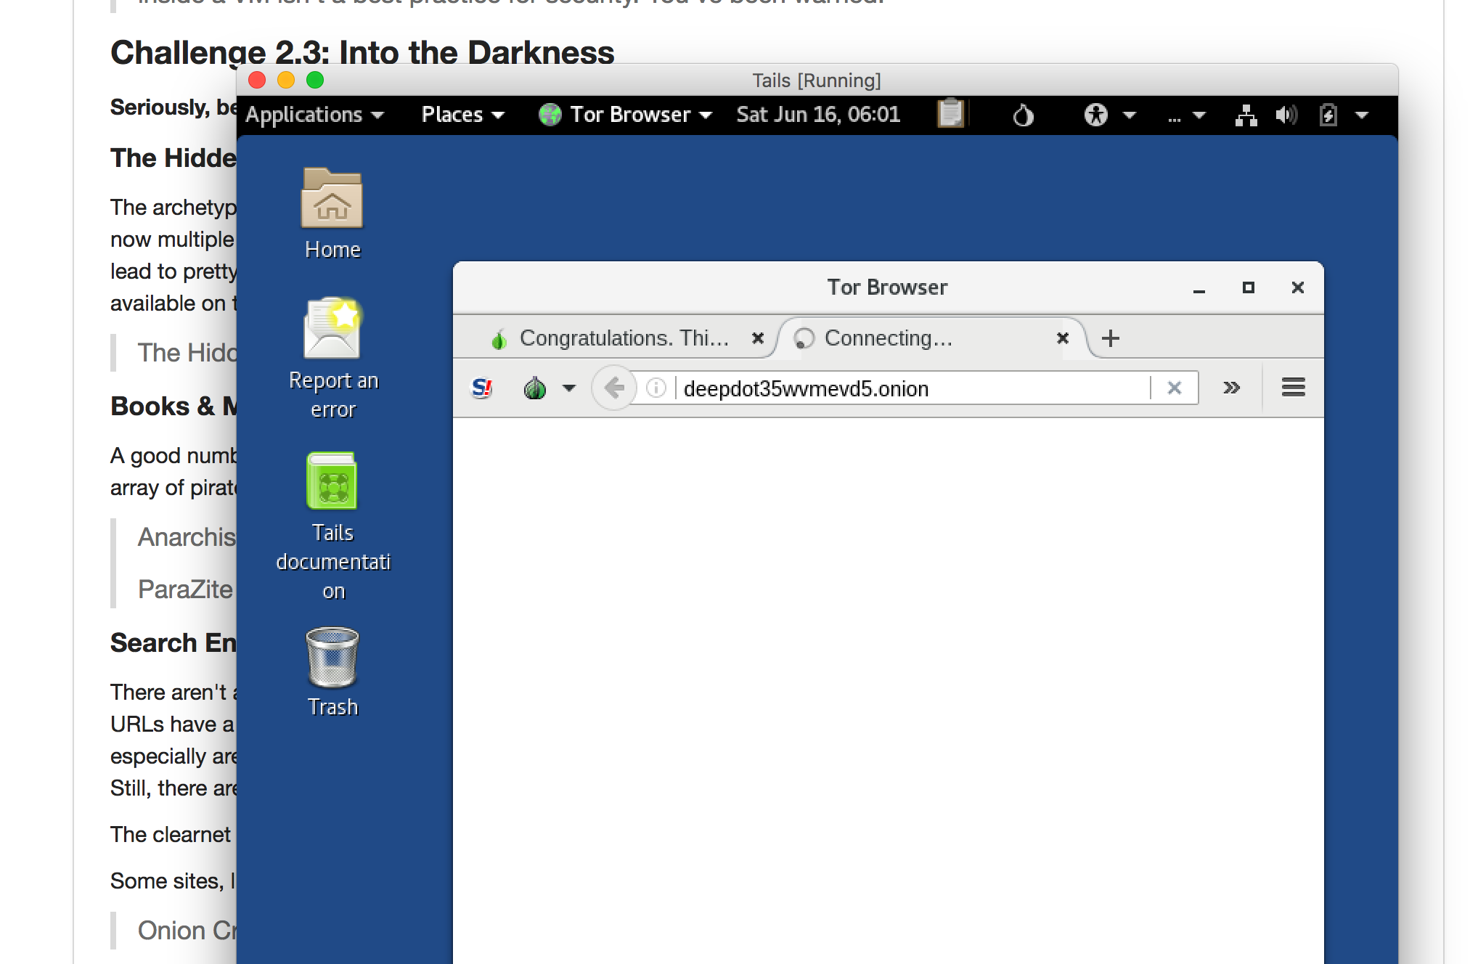

Tried going to : DeepDotWeb: <http://deepdot35wvmeyd5.onion/> but page wouldn’t load.

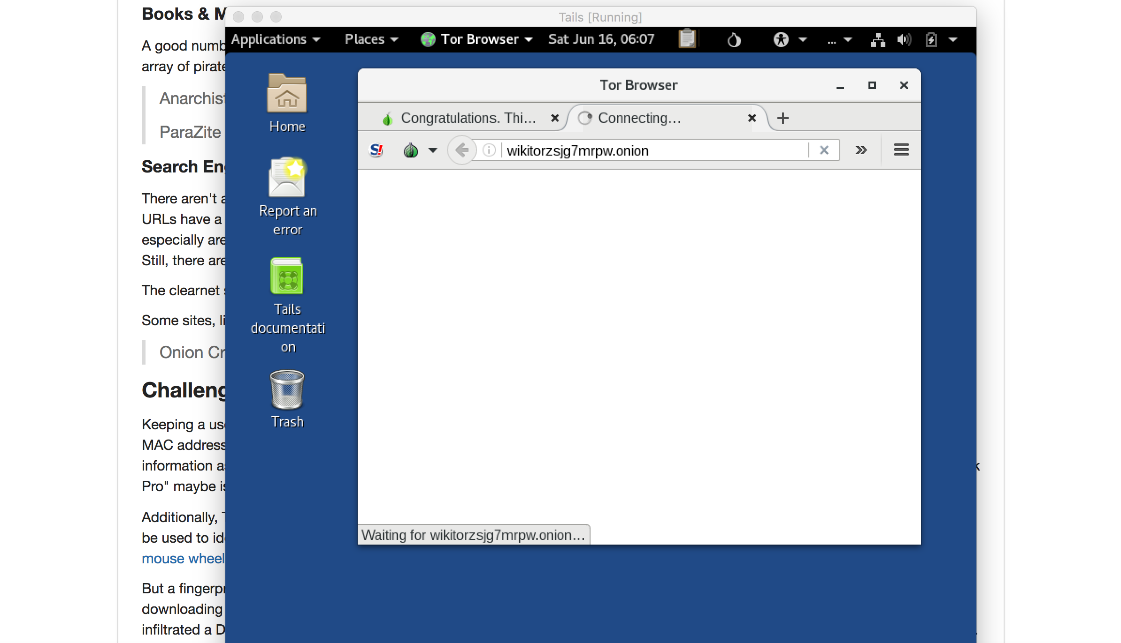

Tried going to DeepDotWeb: <http://deepdot35wvmeyd5.onion/> but it wouldn’t load.